# **Java Variables – Interview Questions – Part 2**

**Explain where variables are created in memory?**

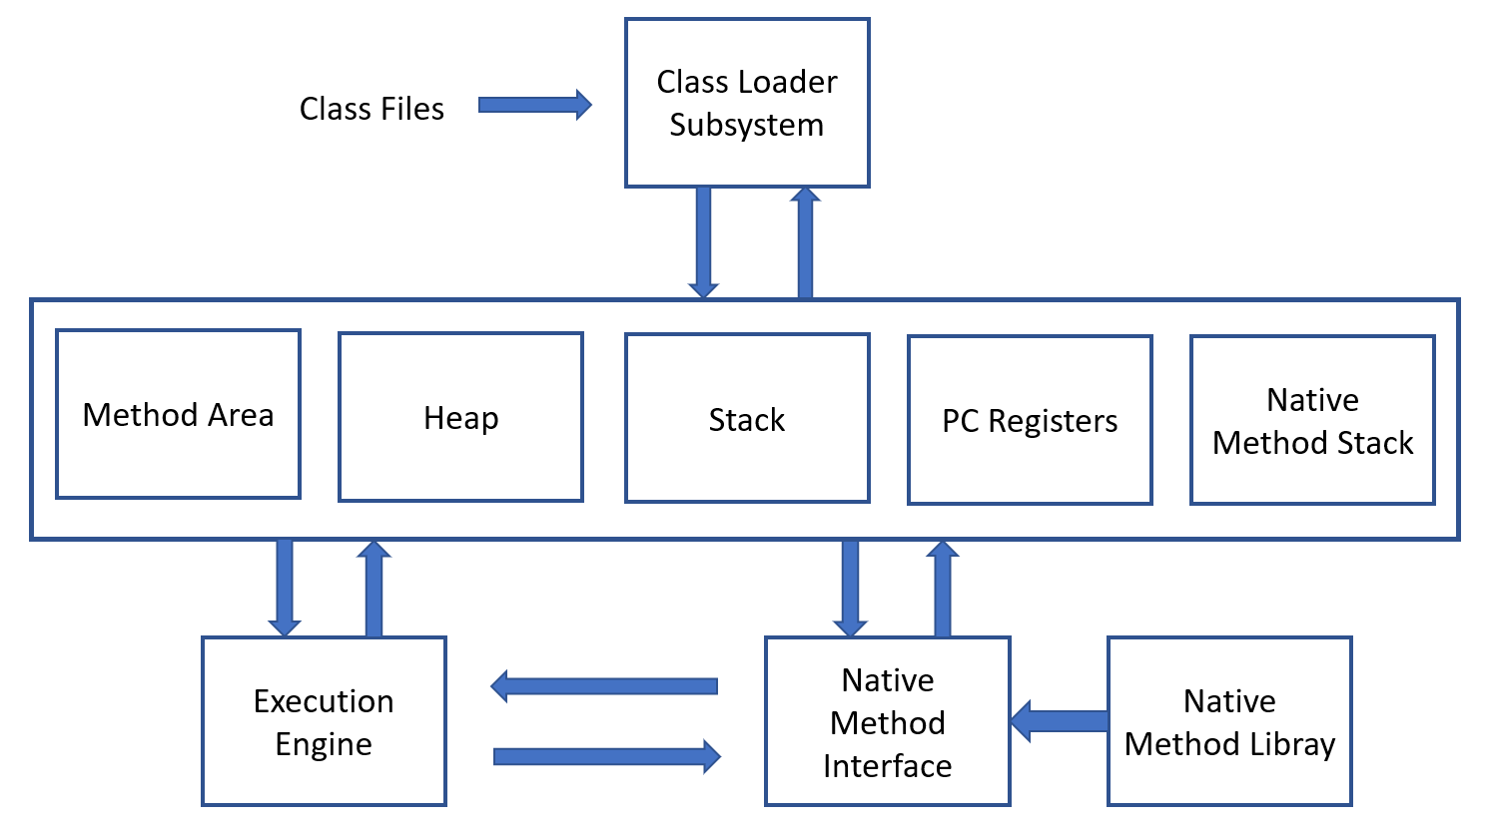

Method Area: It stores all the class code, method code and class variables declared.

Heap Memory: It stores all the objects created.

JVM stack Area: It stores the information of methods at run time. For example, the method variables initiated at run time.

**What is final variable?**

Ans: If a variable is declared as final variable, then you can not change its value. It becomes constant.

Example:

**public** **class** JavaExamples {

**static** **final** **int** ***a*** = 6;

**public** **static** **void** main(String[] args) {

***a*** = 7; //Error: The final field javaexamples.a cannot be assigned

System.***out***.println("a value is "+***a***);

}

}

**How to define a constant variable in Java?**

The variable should be declared as static and final. So only one copy of the variable exists for all instances of the class and the value can't be changed also.  
  
static final int MAX_LENGTH = 50; is an example for constant.

**What are the default values of class variables, instance variables, local variables and block variables in java?**

There is no default value for local variables.

**public** **class** JavaExamples {

**static** **int** *a*;

**int** b;

**public** **static** **void** main(String[] args) {

System.***out***.println("a value is "+*a*);

JavaExamples je = **new** JavaExamples();

System.***out***.println("b value is "+je.b);

**int** c;

System.***out***.println("c value is "+c); //Error: The local variable c may not have been initialized

**for**(**int** i=0;i<4;i++) {

**int** d;

System.***out***.println("d value is "+d); //Error: The local variable d may not have been initialized

}

}

}